Microsoft logo

Robotic Process Automation in a Day

Lab 5 – Connect with API world. Use Outlook email to trigger desktop flows and pass input

30 mins

May 2023

Applies to Power Automate Desktop v. 2.31.105.23101 ([more](https://learn.microsoft.com/en-us/power-platform/released-versions/power-automate-desktop))



This document is provided “as-is.” Information and views expressed in this document, including URL and other Internet Web site references, may change without notice. You bear the risk of  
using it. Some examples are fictitious and are for illustration only. No real association is intended  
or inferred. This document does not provide you with any legal rights to any intellectual property in any Microsoft product. You may copy and use this document for your internal reference purposes.

© 2021 Microsoft Corporation. All rights reserved.

## Lab Overview

You will complete the following tasks in this lab:

* Create a new Cloud flow that initiates the invoicing process via receipt of an email
* Integrate the Desktop flow from Lab 3 into the Cloud flow
* Perform a test run of the new Cloud flow

## Prerequisites

This lab builds on top of previous labs – ensure these labs are complete.

## About Solutions

This lab introduces a concept called Solutions. Solutions are how customizers and developers author, package, and maintain units of software that extend Microsoft Dataverse. For example, Dynamics 365 for Sales, Marketing, Customer Service apps are composed of solutions. Customizers and developers distribute solutions so that organizations can use Microsoft Dataverse to install and uninstall the business functionality defined by the solution. For additional information about Solutions, please see the following link: <https://docs.microsoft.com/en-us/powerapps/developer/common-data-service/introduction-solutions>

# Connect with API world. Use Outlook email to trigger Desktop flow and pass input

1. Open the test profile in a browser and navigate to <https://powerautomate.microsoft.com>.
2. Select Solutions in the left menu and then open the **Invoice processing solution <MyUserName>** solution you have created in lab 4.

1. Click **+New** -> **Automation** -> **Cloud flow** -> **Automated** menu to create a new cloud flow.

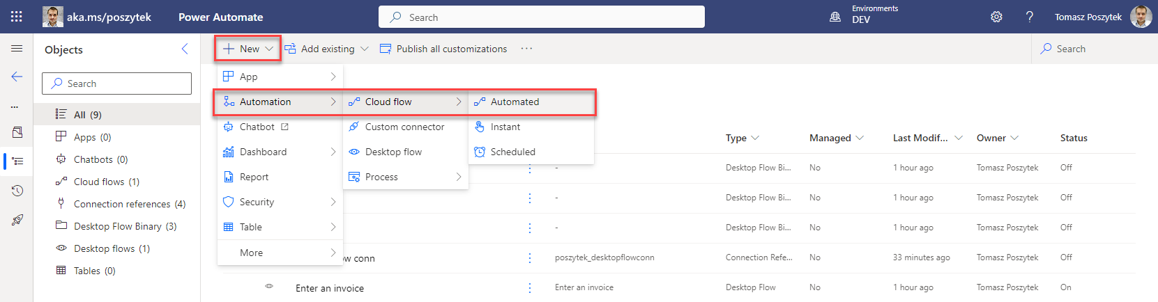

1. Name your new flow Use Outlook email to trigger Desktop flow and select when a new email arrives (V3) as the trigger event then click **Create** button

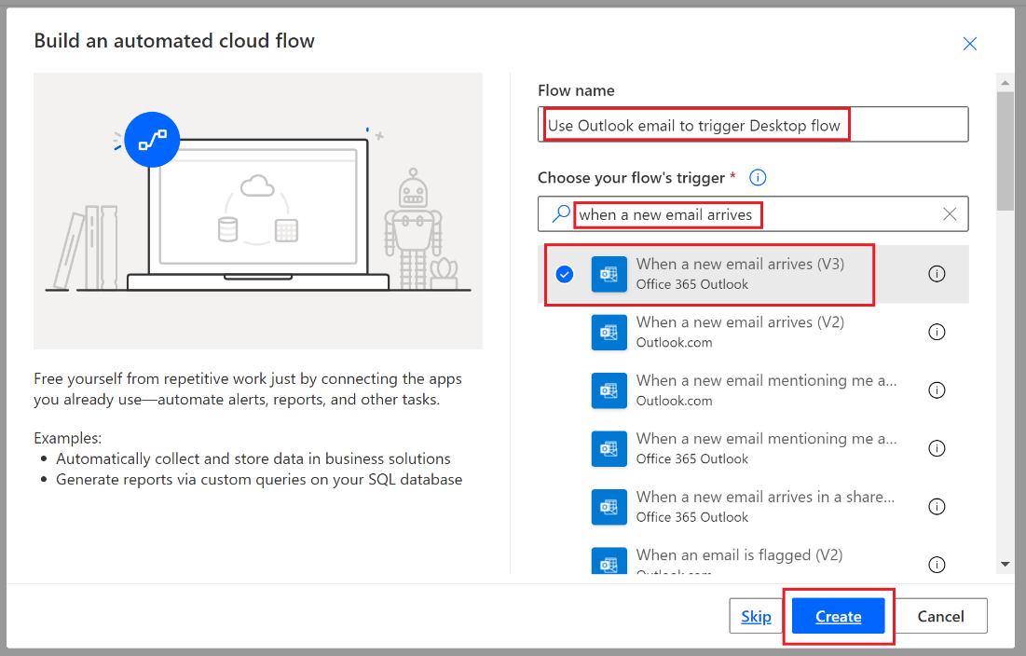

1. You will be in the flow designer now. Sign in with your Outlook account.
2. In the trigger card of **When a new email arrives (V3)**, click Show advanced options.

**Note:** You can check your connection by clicking the ellipsis icon (…) on the top right corner of the box.

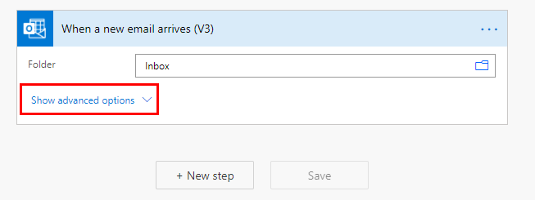

1. Select Yes for Include Attachments and Has Attachment or Only with Attachments (depends on the version of the Outlook connector)

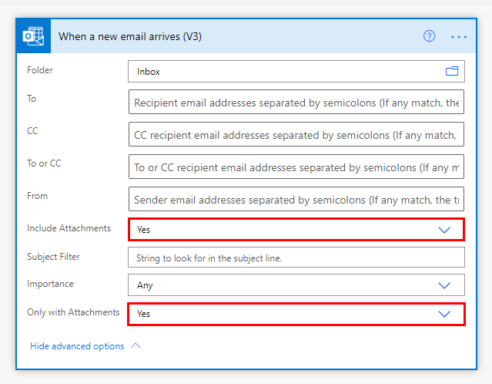

1. Enter new invoice in Subject Filter box.

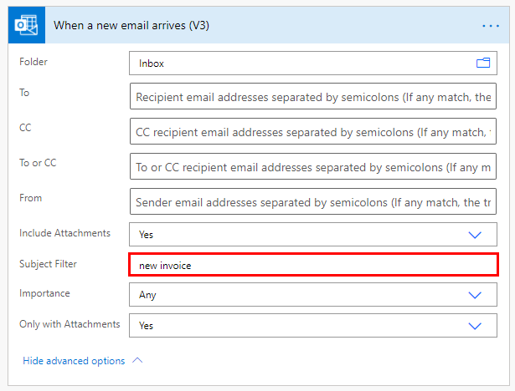

1. Click +New step.

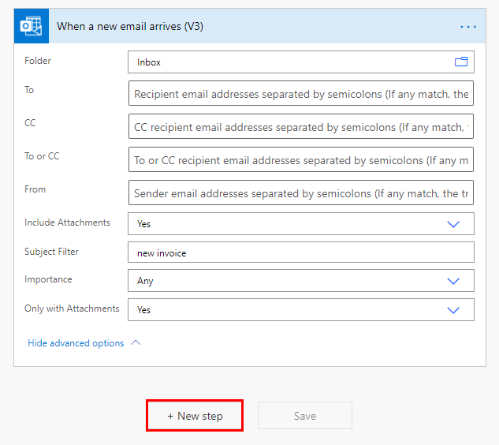

1. Search for Desktop flow in the search bar and select Run a flow built with Power Automate Desktop.

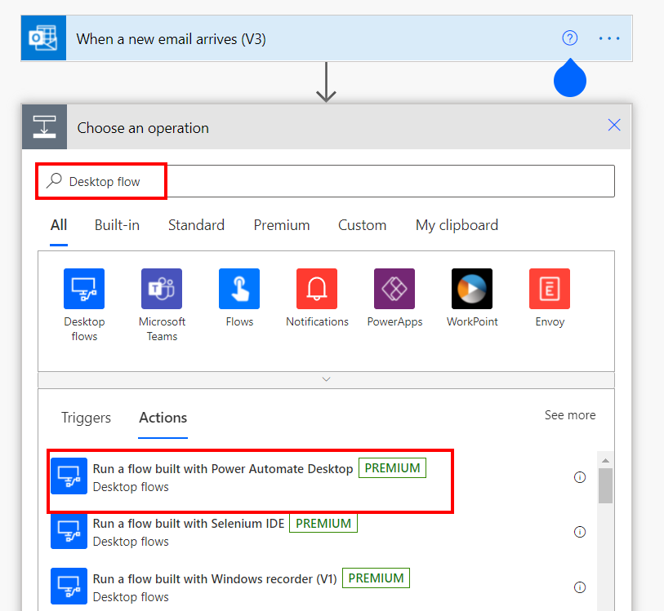

**Note:** You may receive a prompt to create a new connection because of building an API flow inside of a solution. Please use the same information that you used when creating connections in previous labs.

1. Under Desktop flow dropdown list, find and select the desktop flow that we have created earlier: Enter an invoice.

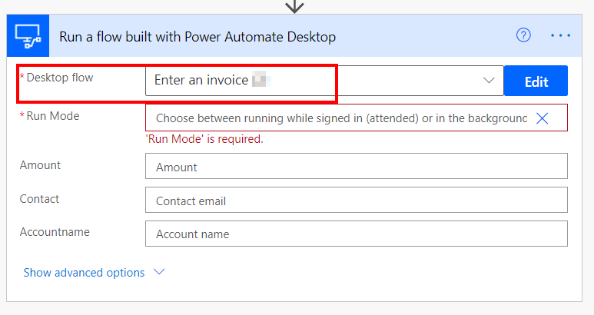

**Note:** if you did not see the name of newly created desktop flows in the dropdown list, you can click the refresh icon next to the search textbox to refresh the list.

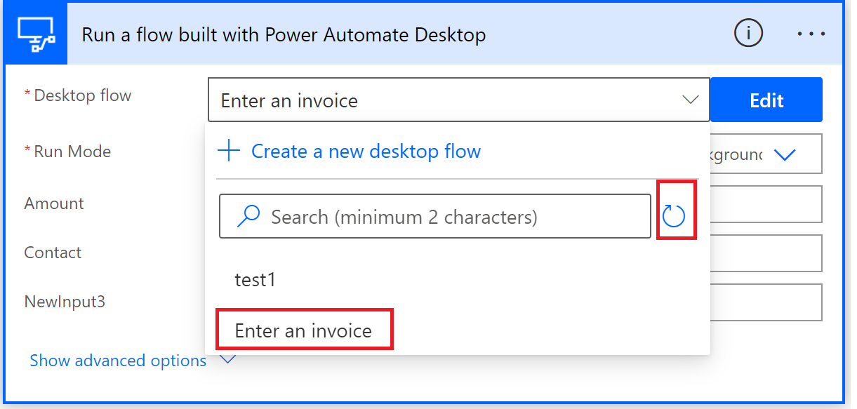

1. Under Run Mode, select Attended – Runs when you’re signed in.

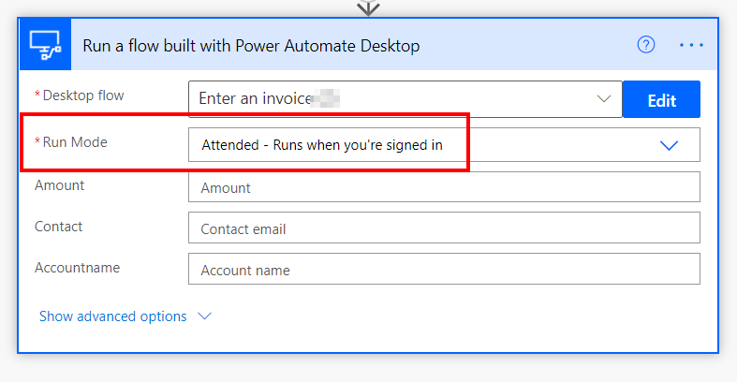

1. Fill the box with these string values: (Note, we will switch in later labs to use Dynamics input values. But for now, we will use static values)

* Amount: 200
* [Contact:](mailto:Contact:b.friday@wingtiptoys.com) b.friday@wingtiptoys.com
* Account name: WingTip Toys

1. Save the flow.

1. Test the flow by clicking Test. Then select **Manually** option and click **Save and Test** button.

1. You will see a flow run history page which is empty. Since this flow has a trigger, the flow will run automatically if that trigger condition happens (when a new email arrives).

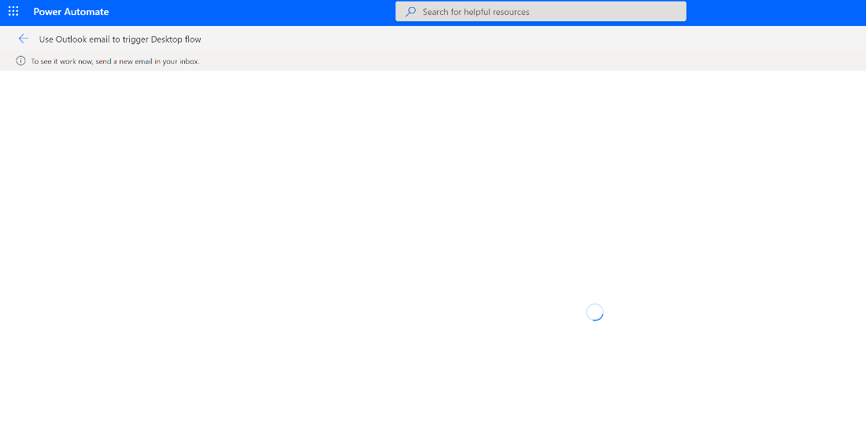

1. Now open an email app to draft an email to send to the inbox of the account that your trigger action is monitoring (which is the account you used to sign in when creating the trigger connection). In the email body, add the newinvoice.jpg file as attachment (you can find this jpg file under the lab data package folder) and enter New invoice in the email title. Click Sendto test out this flow.

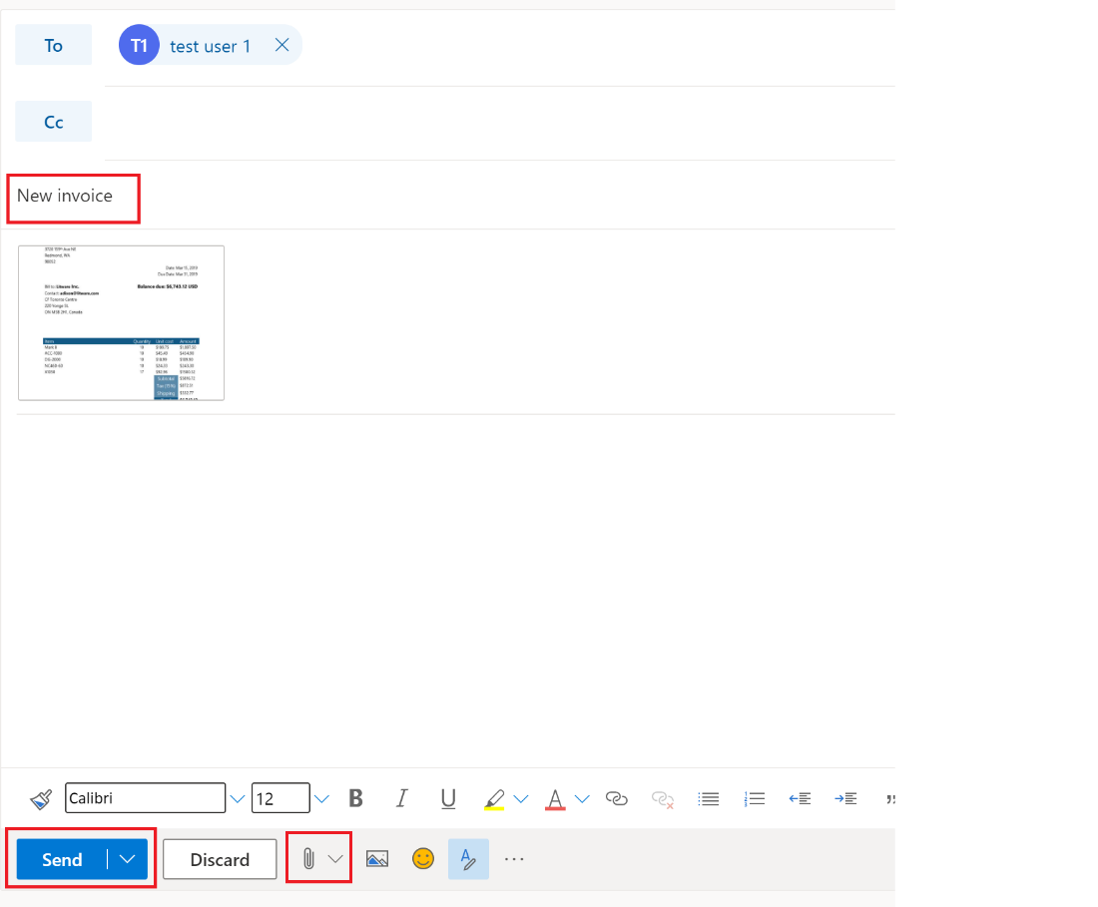

1. Once the email is received by the inbox that your flow trigger is monitoring, it will trigger the flow run automatically. Go back to the flow run history page, you will see that your flow should run successfully and launch the desktop flow on your computer as well.

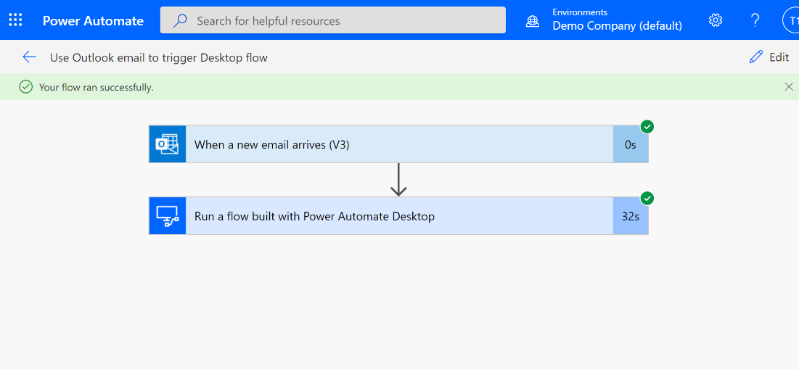

**Note:** Sometimes, in demo instances, emails may be blocked due to spam concerns. If you receive an error sending an email, please try to send it from another account and be sure to include the attachment and correct Subject line.

Check your knowledge

Lab 5

5 mins

1. Using Solutions to manage your flows is a best practice, but what is the reason we must use solution in this lab? Is it because the AI builder model in the next lab will only be supported within solution-based flow?
2. True
3. False

Answer: A. True, calling an AI Builder model requires the use of a solution-aware flow.

1. How do you check your Outlook connection after signing into your outlook account in this lab to ensure you are using the right account?
2. Open your Outlook manually
3. Click Show advanced options
4. Click the outlook icon in cloud flow
5. Click the ellipsis icon (…) on the top right corner of the box

Answer: D. Click the ellipsis icon (…) on the top right corner of the box. Here you will see the email address that was used to create the connection.

Information in this document, including URL and other Internet Web site references,  
is subject to change without notice. Unless otherwise noted, the example companies, organizations, products, domain names, e-mail addresses, logos, people, places, and events depicted herein are fictitious, and no association with any real company, organization, product, domain name, e-mail address, logo, person, place or event is intended or should be inferred. Complying with all applicable copyright laws is the responsibility of the user. Without limiting the rights under copyright, no part of this document may be reproduced, stored in or introduced into a retrieval system, or transmitted in any form or by any means (electronic, mechanical, photocopying, recording, or otherwise), or for any purpose, without the express written permission of Microsoft Corporation.

Microsoft may have patents, patent applications, trademarks, copyrights, or other intellectual property rights covering subject matter in this document. Except as expressly provided in any written license agreement from Microsoft, the furnishing of this document does not give you any license to these patents, trademarks, copyrights, or other intellectual property.

The names of manufacturers, products, or URLs are provided for informational purposes only and Microsoft makes no representations or warranties, either expressed, implied, or statutory, regarding these manufacturers or the use of the products with any Microsoft technologies.  
The inclusion of a manufacturer or product does not imply endorsement of Microsoft of the manufacturer or product. Links may be provided to third party sites. Such sites are not under the control of Microsoft and Microsoft is not responsible for the contents of any linked site or any link contained in a linked site, or any changes or updates to such sites. Microsoft is not responsible for webcasting, or any other form of transmission received from any linked site. Microsoft is providing these links to you only as a convenience, and the inclusion of any link does not imply endorsement of Microsoft of the site, or the products contained therein.

© 2021 Microsoft Corporation. All rights reserved.

Microsoft and the trademarks listed at https://www.microsoft.com/enus/legal/intellectualproperty/Trademarks/Usage/General.aspx  
are trademarks of the Microsoft group of companies. All other trademarks are property of their respective owners.